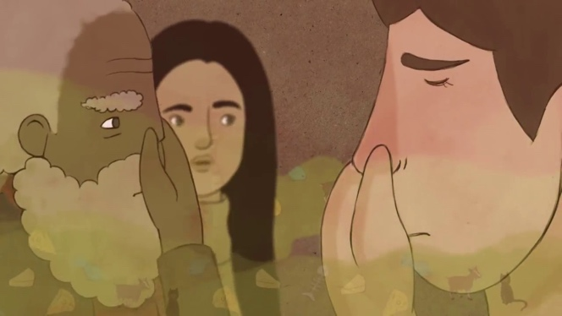
What Causes Body Odour?
By: Mel Rosenberg
https://tinyurl.com/bodyodour141

- The unpleasant human odour we refer to as “body odour” comes mainly from the ____________ (1 point).
  - The groin
  - The feet
  - The whole body
  - The armpits
- Eccrine and apocrine refer to two different kinds of ____________ (1 point):
  - Smells
  - Bacteria
  - Sweat glands
  - Odour profiles
- Eccrine glands are found all over your skin and secrete mainly ______________ and ______________. The sweat apocrine glands secrete is full of ______________ and ______________. (2 points)
- Body odour develops ___________. (1 point)
  - With puberty
  - At birth
  - As a young child
  - With the eruption of our permanent teeth
- Corynebacteria, staphylococci, and micrococci are ___________. (1 point)
  - Types of sweat glands
  - Types of bacteria
  - Human skin cell lines
  - Types of odours
- Some people have little or no body odour because of their __________. (1)
  - Genetic makeup
  - Sleeping habits
  - Height
  - None of the above
- ______________________ increases the ratio of apocrine to eccrine sweat, so body odour can be more intense when you’re __________________. (2 p)
- Antiperspirants work by _____________. (1 point)
  - Forming tiny gel plugs that block sweat glands
  - Application of enzymes that break down the odours
  - Trapping the odours on the skin
  - Oxidizing the odours produced
- How is body odor produced? What body parts and other factors are involved? (2 points)

__________________________________________________________________________________________________________________________________________________________________

